COMPLETION REPORT

BACKGROUND/RATIONALE
The Dentistry with Care Society, based in Vancouver, Canada, in collaboration with Marinduque International and Philippine Medical Association of Chicago conducted a Medical -Dental Mission to the Philippines on January 30, 2014 to February 7, 2014. A total of 10,575 patients (medical/surgical/optha/dental) were treated .

In line with the objectives of the Society, the Dental Mission was held to improve the quality of oral health condition of marginalized population in a developing nation by providing free dental services. The outreach activity also promoted preventive health care information thru education, instructions & support of community programs.

PROJECT SITES
The dental mission was held in two provinces, Marinduque and Batangas, both located in northern central Philippines. In Marinduque, the dental mission was held for four successive days in the five municipalities comprising of Buenavista, Boac, Mogpog, Santa Cruz, and Torrejos. The following week, a whole day mission trip was held in Kipsi Elementary School in Batangas City.

OUTREACH PROJECT BENEFICIARIES
The beneficiaries of this outreach activity were the indigents, mostly families of farmers and fisherfolks, who do not have access to dental health services. A total of 3,000 dental patients (adults & children) from the local community, mostly remote poverty-stricken villages in the areas were treated. The local organizing committees conducted the preliminary selection of patients for the mission.

A generalized occurrence of multiple caries were observed on the mission participants, which included children as young as 6 years old. This can be attributed to several factors such as (1) lack of regular dental check up/ hygiene due to limited government support on dental services; ( 2) lack of education & information campaign regarding oral health; and (3) dietary practices of locals which is high sugar and carbohydrate-rich foods and consumption of carbonated drinks (pop colas) which is believed to be thirst-quenching in tropical countries like the Philippines.

PARTICIPATING INSTITUTIONS & ORGANIZATIONS
The Dental Mission was in collaboration with The Dental Mission Project-University of British Columbia, College of Dentistry and Patterson Dental. With this project, two portable dental chairs and two units of portable dental equipments were provided, and it was used mainly for restorative (fillings) procedures and difficult surgical extractions. Henry Schein and Colgate (Canada) donated dental supplies for the Mission.

This Mission was held with the strong support of the local government and health associations in the two provinces. For this year, The Dentistry with Care Society collaborated with the Marinduque International Association and the Philippine Medical Association of Chicago, whose group simultaneously conducted the Medical Mission. A group of volunteer local dentists from the Filipino-Chinese Dental Foundation, Inc. also joined hand in hand with Canadian dentists in treating patients. In Batangas province, Dr. Willord Tomulac and his team (The Lord’s Vineyard Charity Church) joined at Kipsi Elementary School to treat elementary students aged 6 to 12 years old.

THE DENTAL MISSION TEAM AND VOLUNTEERS
There were a total of 18 Canadian volunteers who flew to the Philippines which included dentists, dental assistants, nurses and other technical and administrative support volunteers. The team was responsible for (1) provision of dental treatments/services; (2) provision of dental equipments, supplies and medicines; and (3)promotion of proper oral health care and nutrition thru information & education campaign; (4) distribution of donated clothings, footwears and toys.

DENTAL TREATMENTS AND SERVICES CONDUCTED
The dental treatments/services covered were as follows: (1)Oral surgery - tooth extractions; (2)Restorative Treatment - dental fillings; (3) Caries Prevention - fissure sealing; (4) Hygiene Treatment- Polishing/Scaling/Gingival Curettage and (5) Oral health education/instructions.

CONCLUSION /ASSESSMENT/RECOMMENDATION
The team worked in collaboration with leading local health providers. This is an intention taken to encourage these groups to promote continuity of our goal to improve caries control and general oral well-being of the underprivileged, most especially the young children who will lead in the future. It is highly recommended to revisit these sites as a vital factor in the evaluation of the attainment of our goal.

DENTAL MISSION IN ACTION – PHOTOS (Attached)

THE DENTAL MISSION TEAM
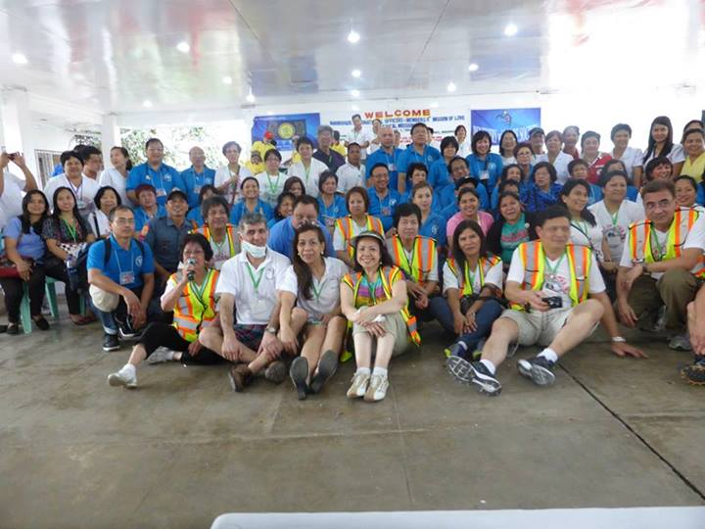

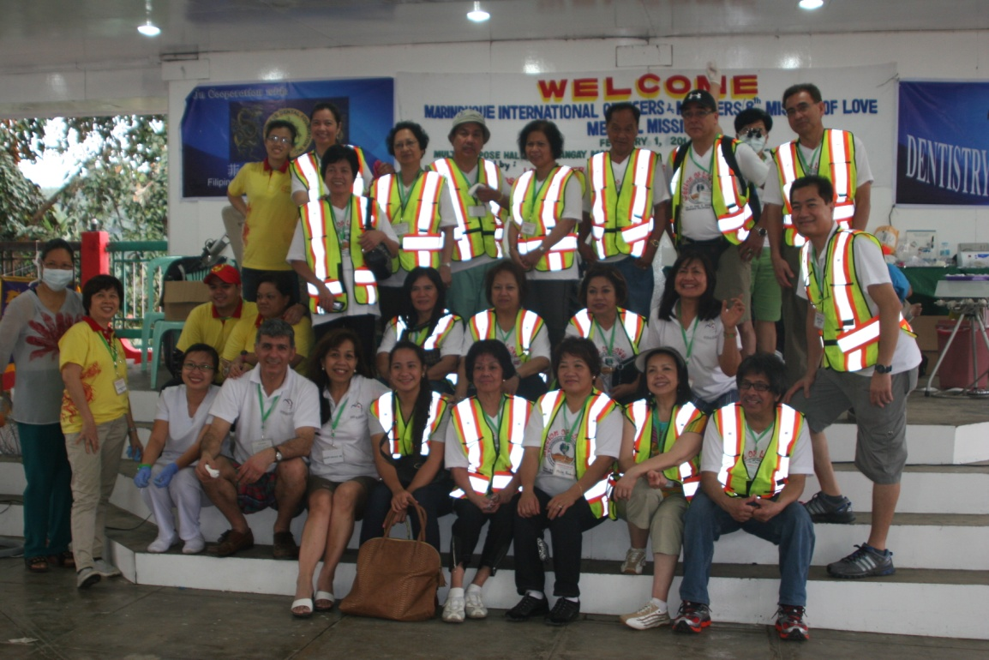

Site: Province of Marinduque

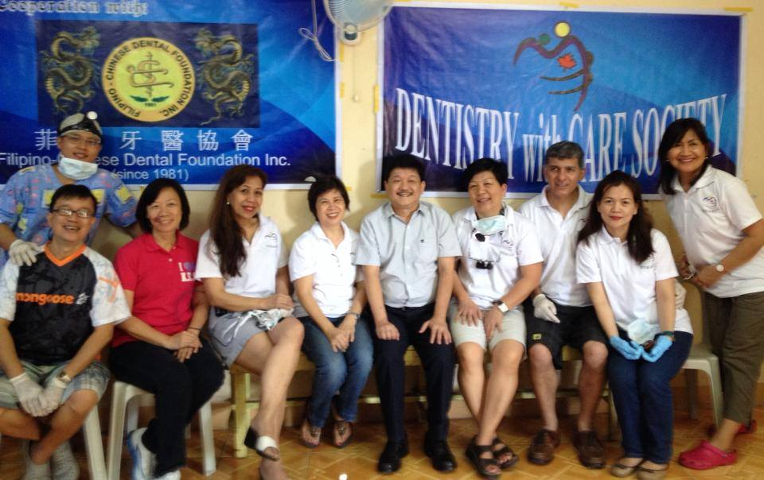

Site: Province of Batangas

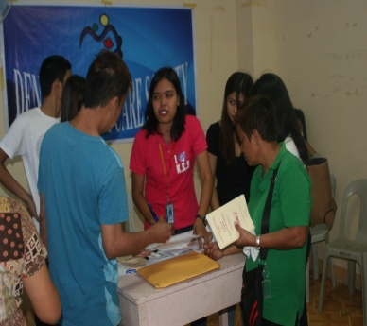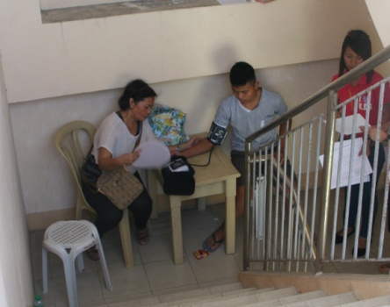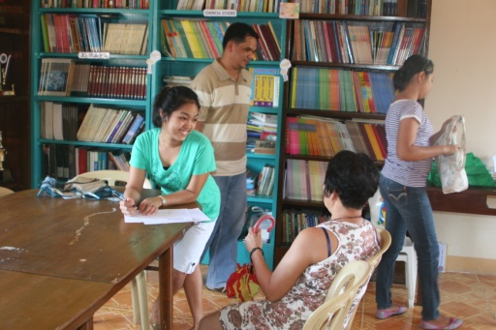

PROJECT SITES: Map of the Philippines showing the provinces of Marinduque
and Batangas

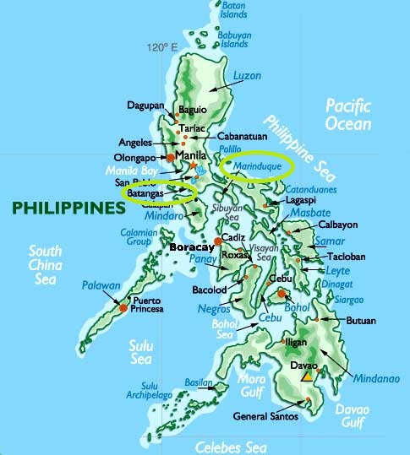

PROJECT SITES: Sceneries & People

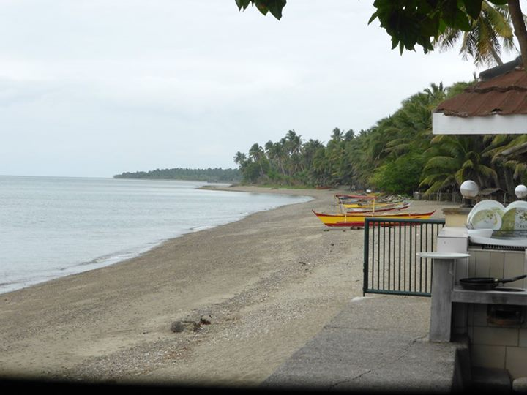

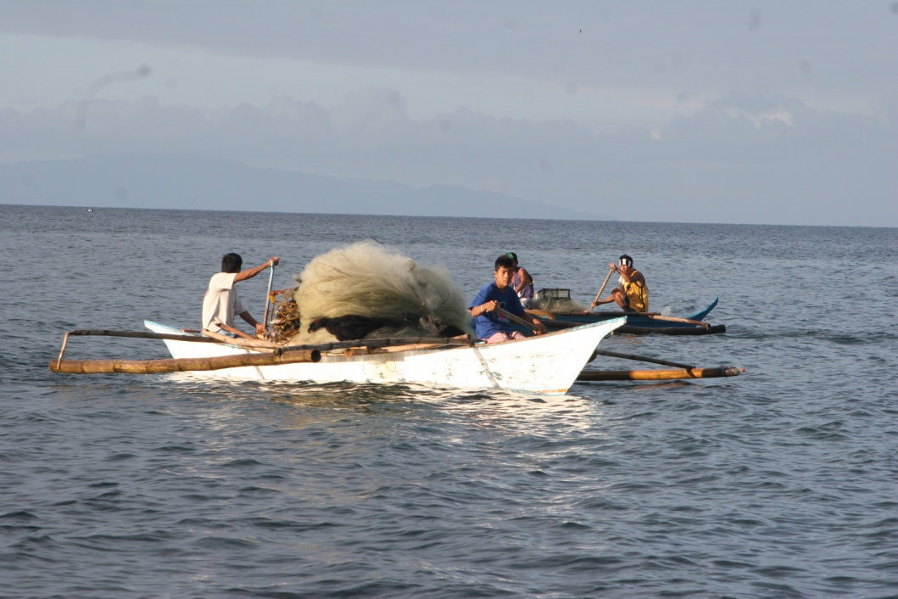
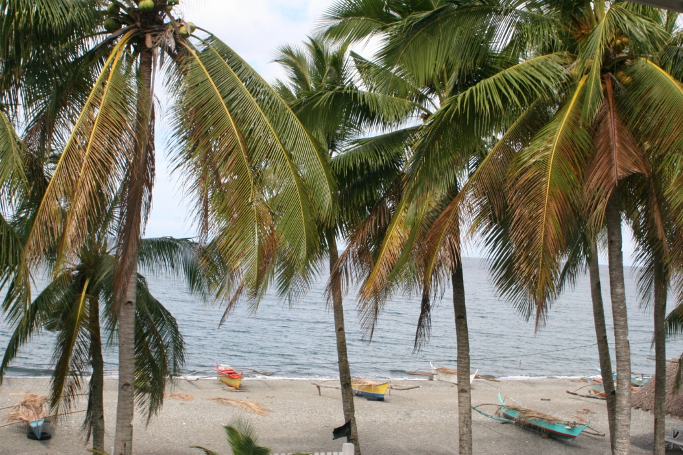

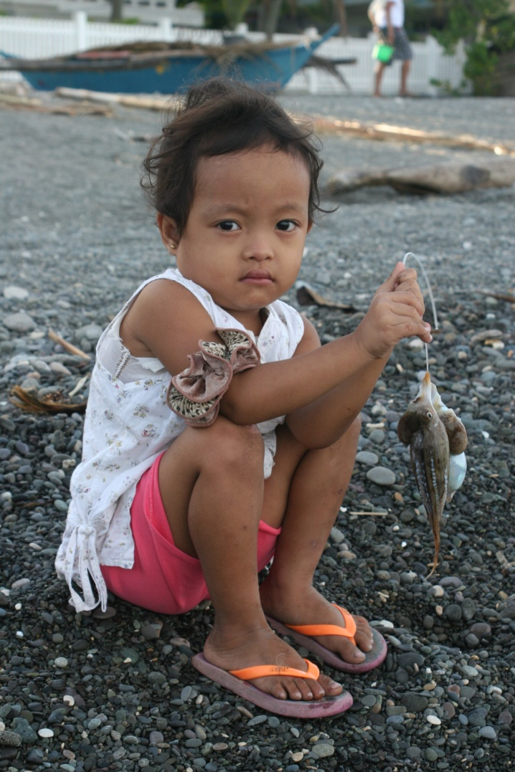

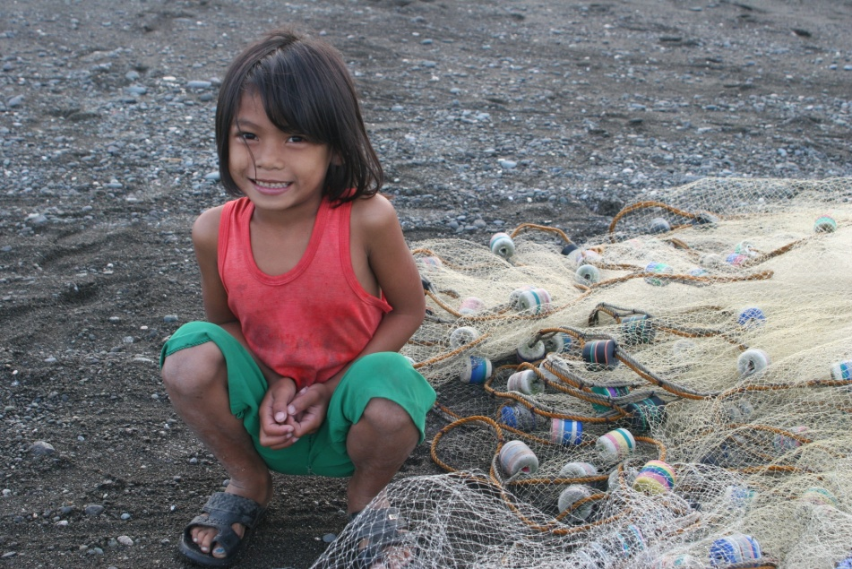
Set-up: Portable Dental Clinic

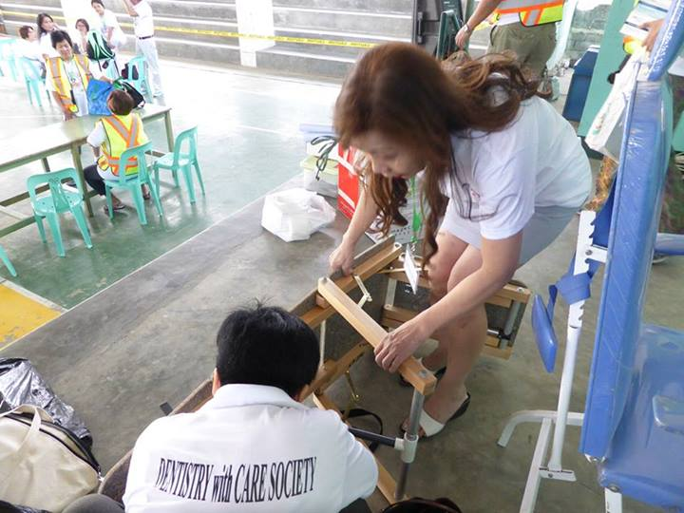

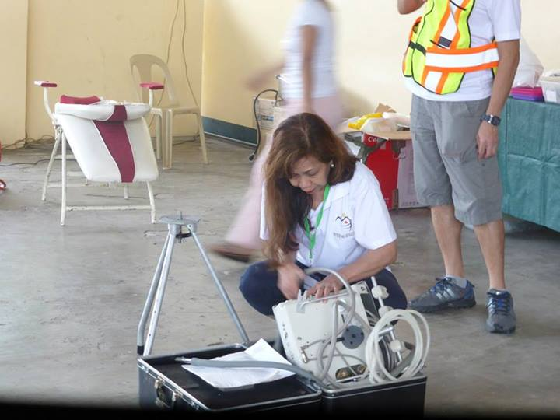
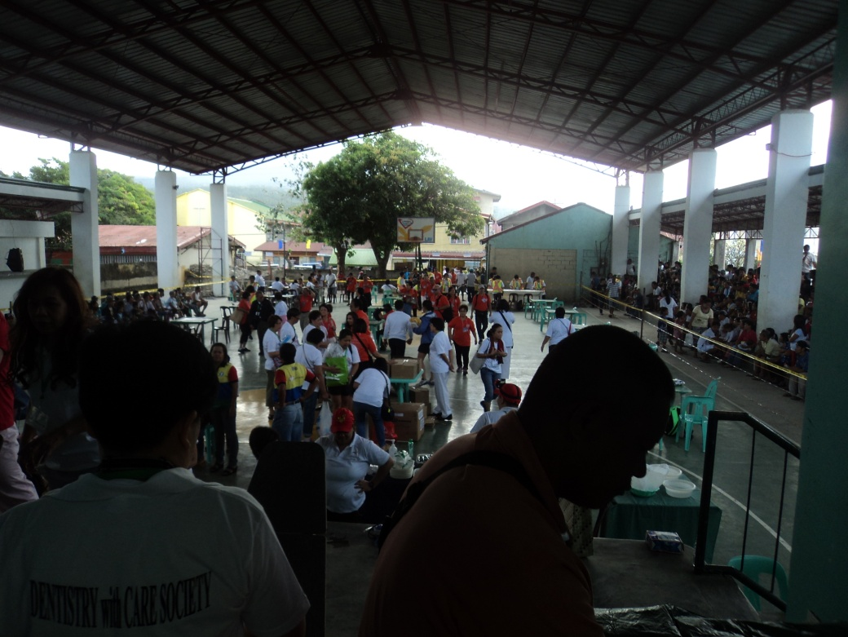

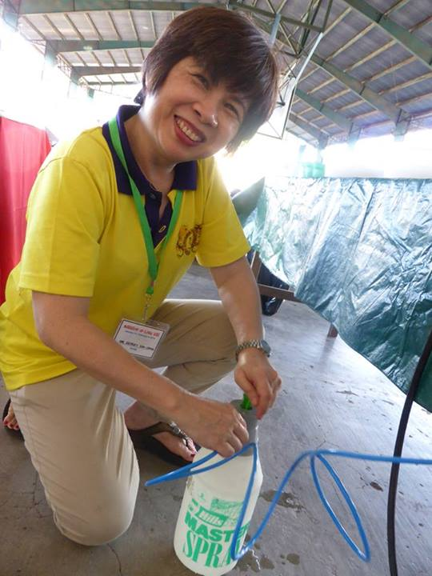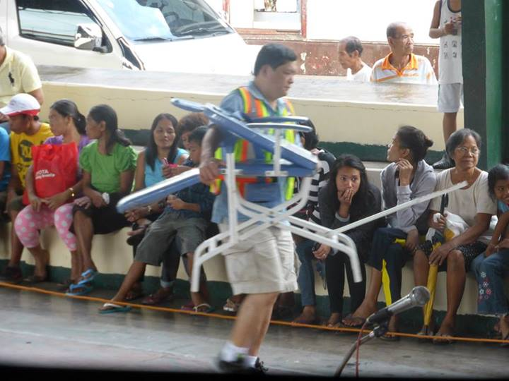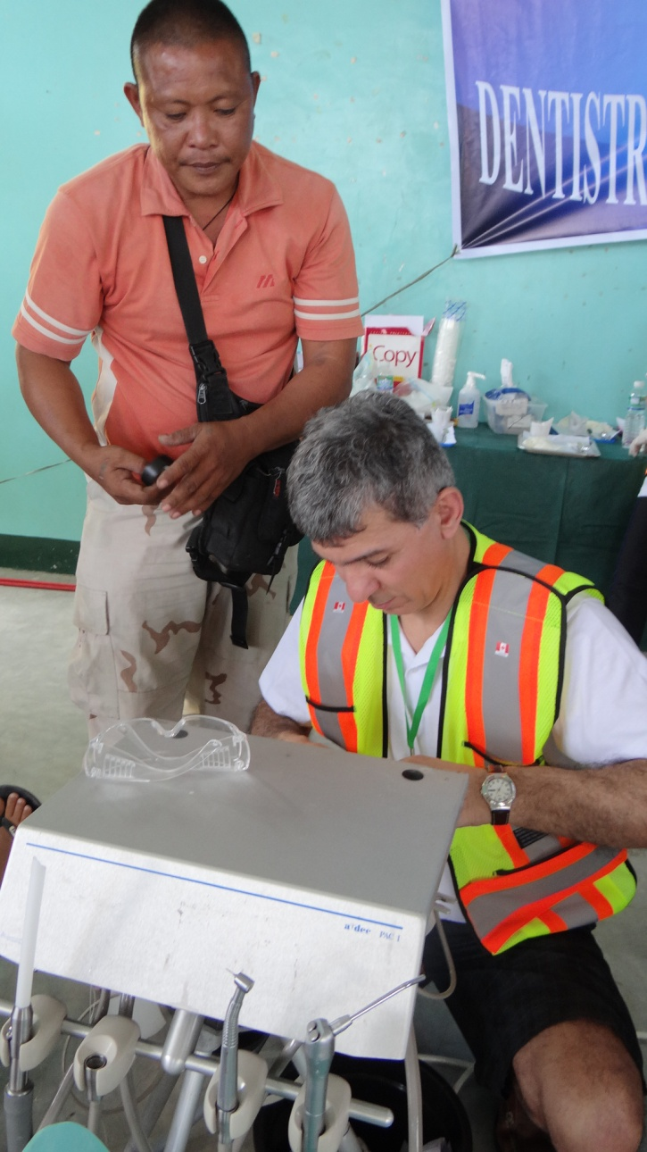

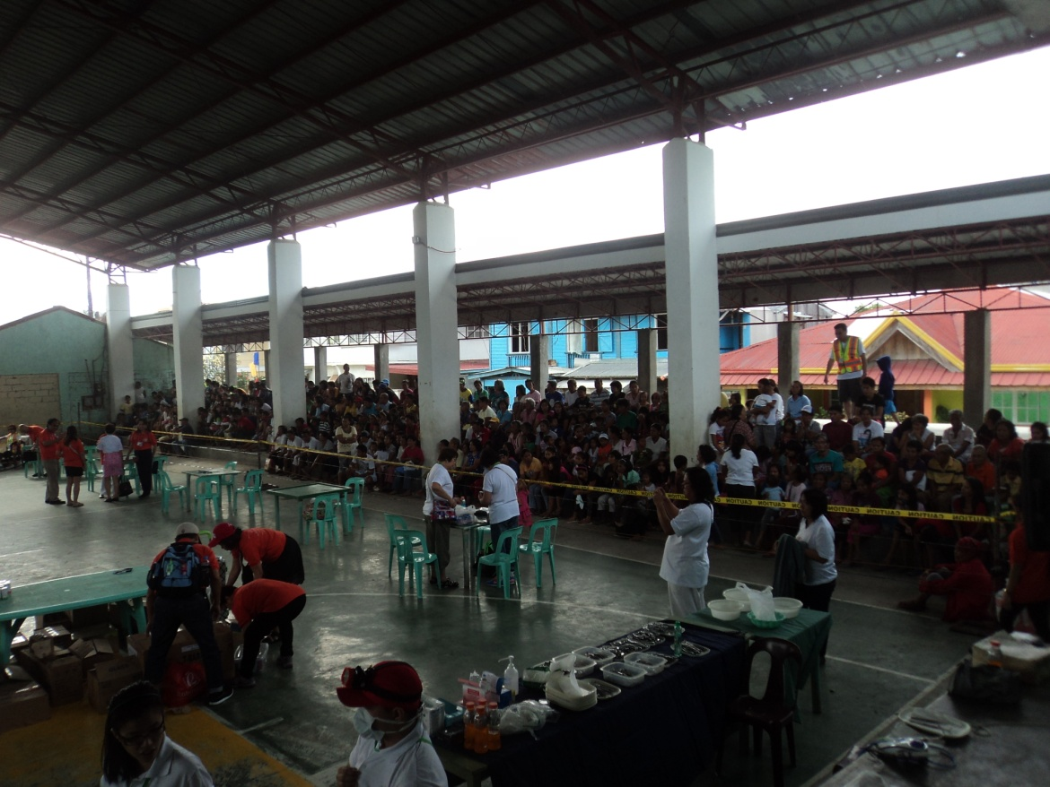

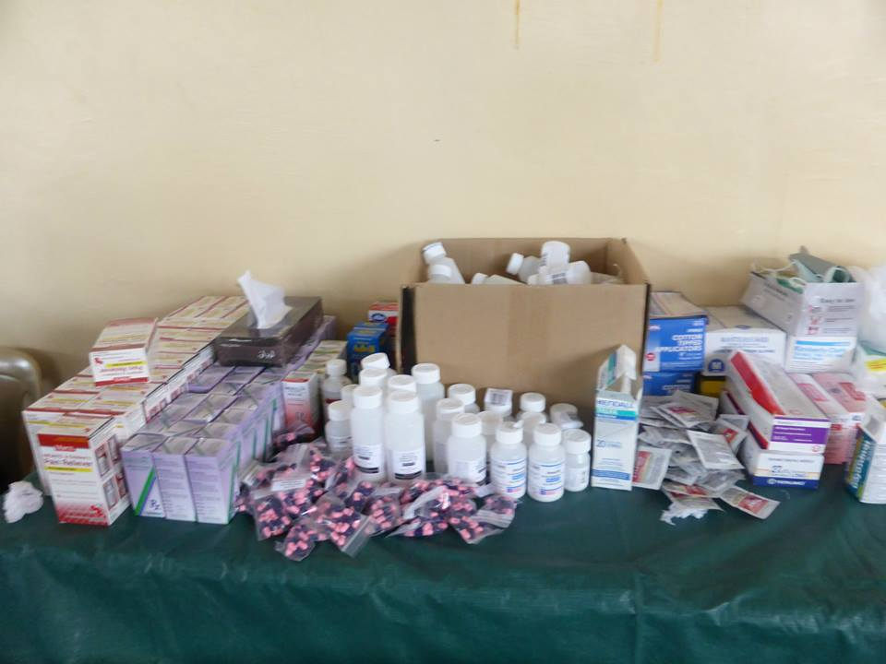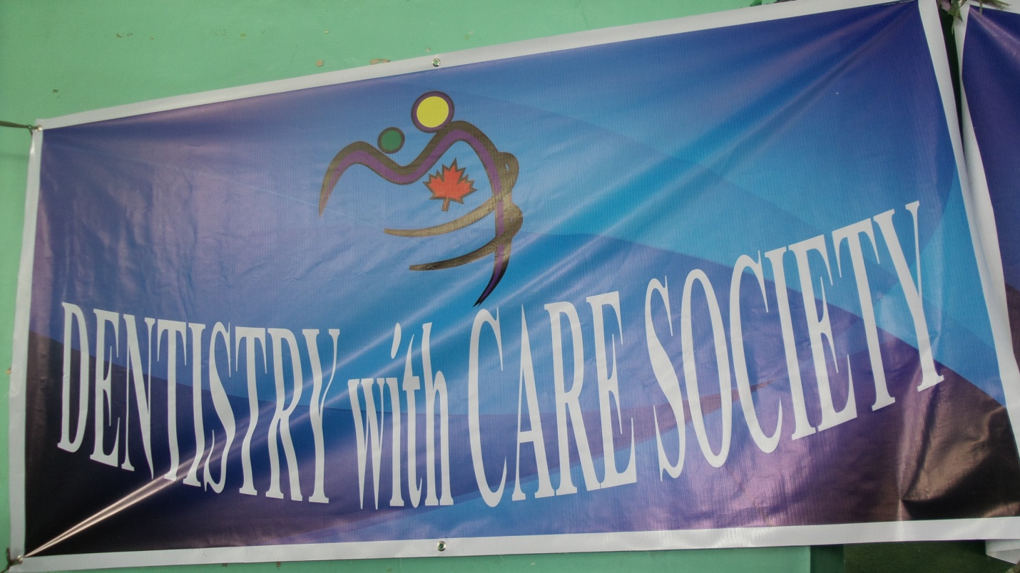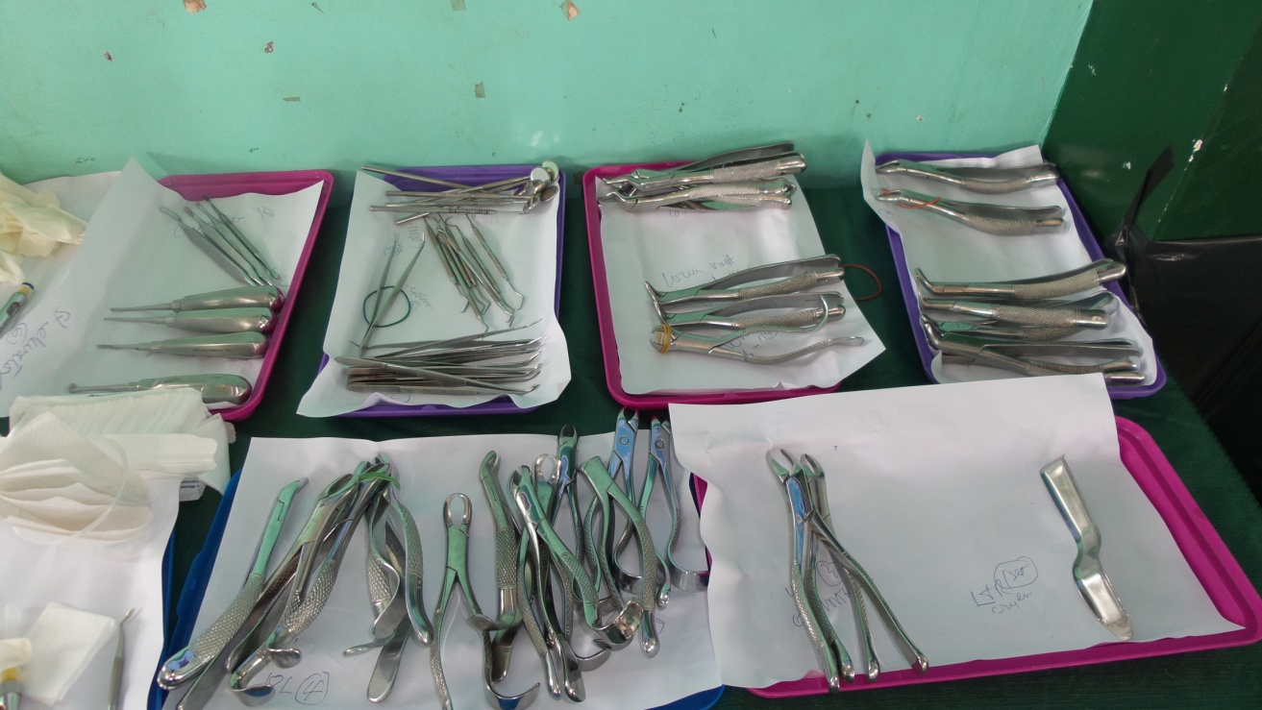

ORIENTATION & PLANNING

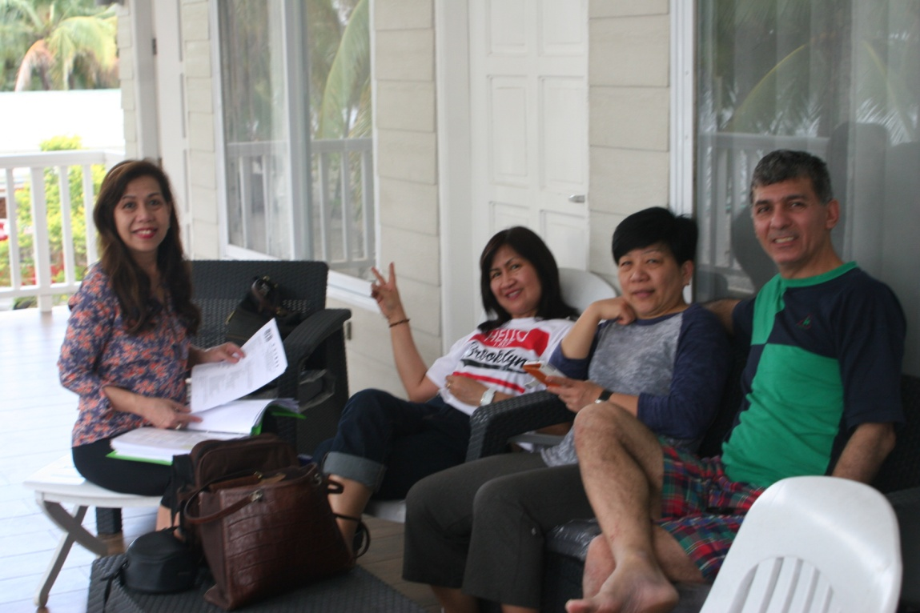

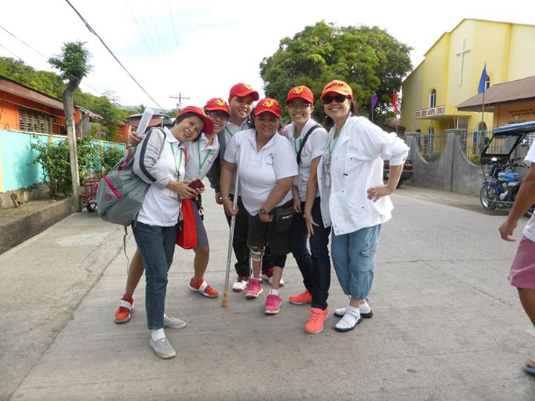
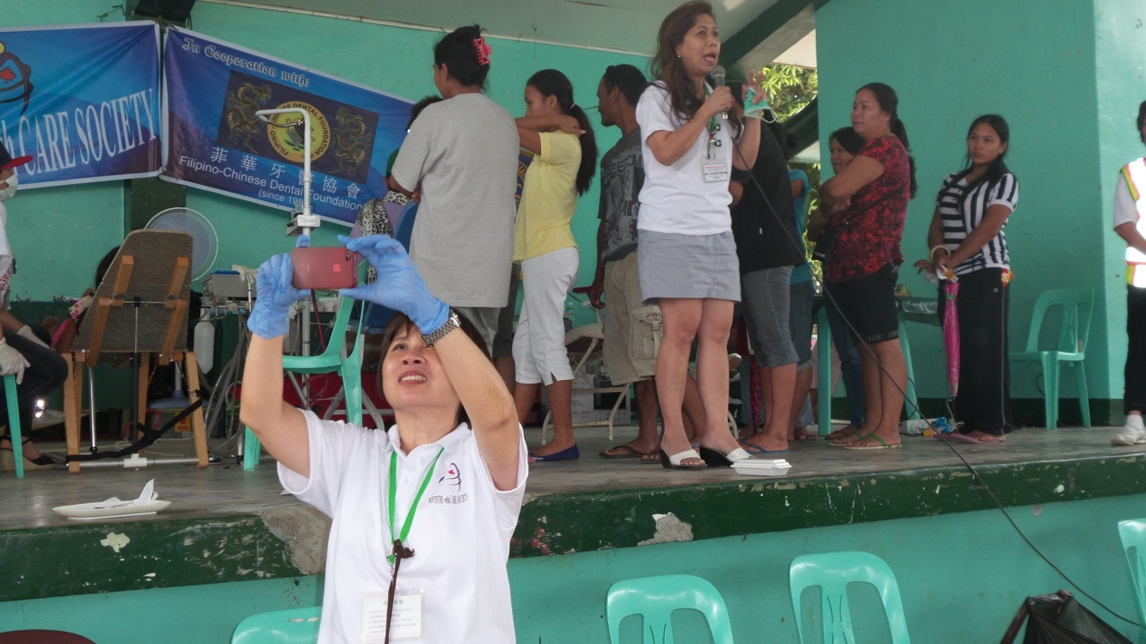

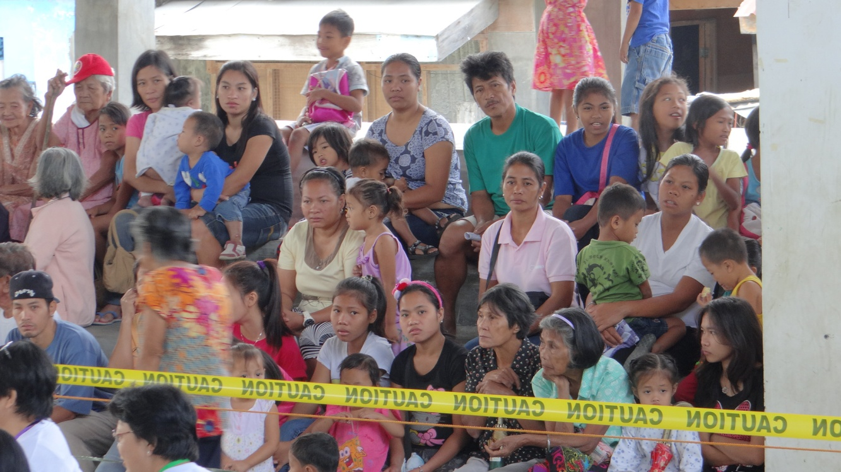

DENTAL TREATMENTS/SERVICES

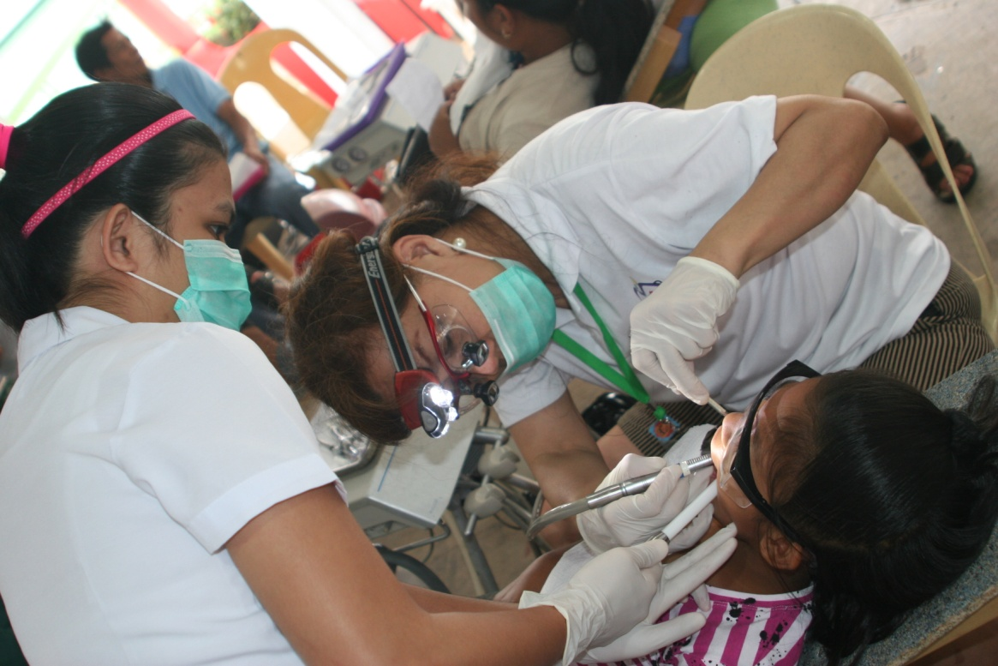

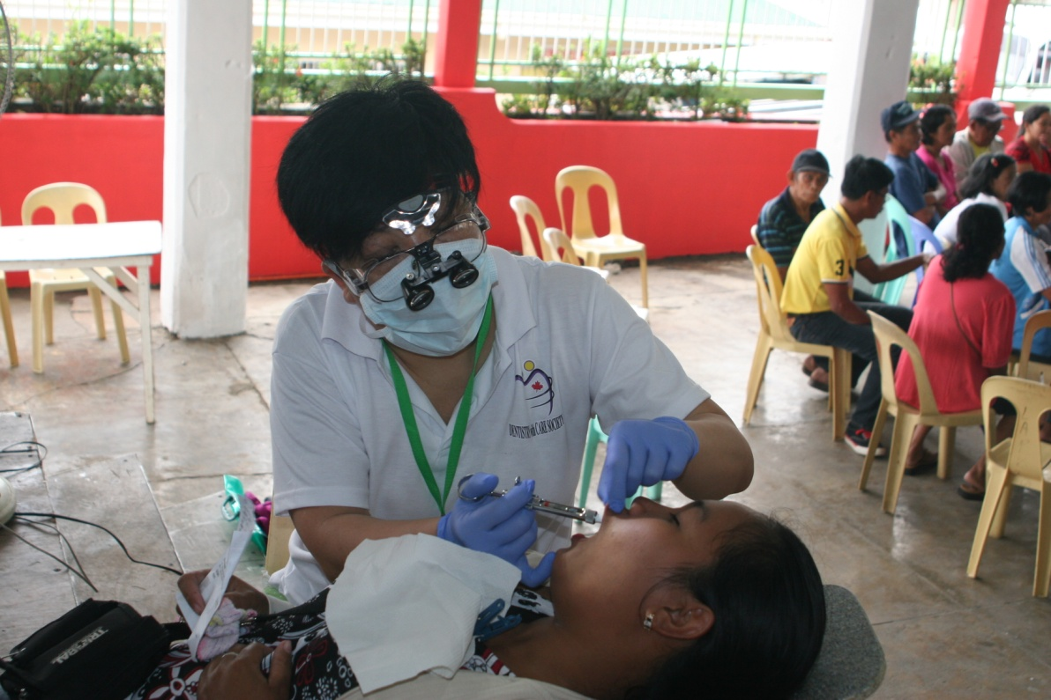
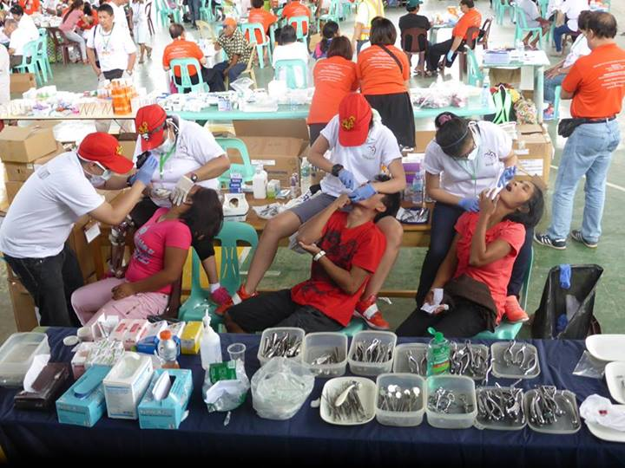

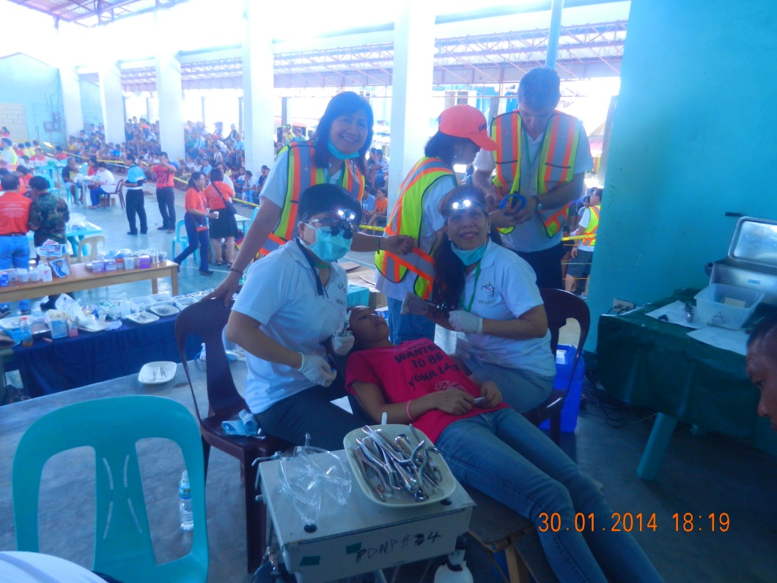

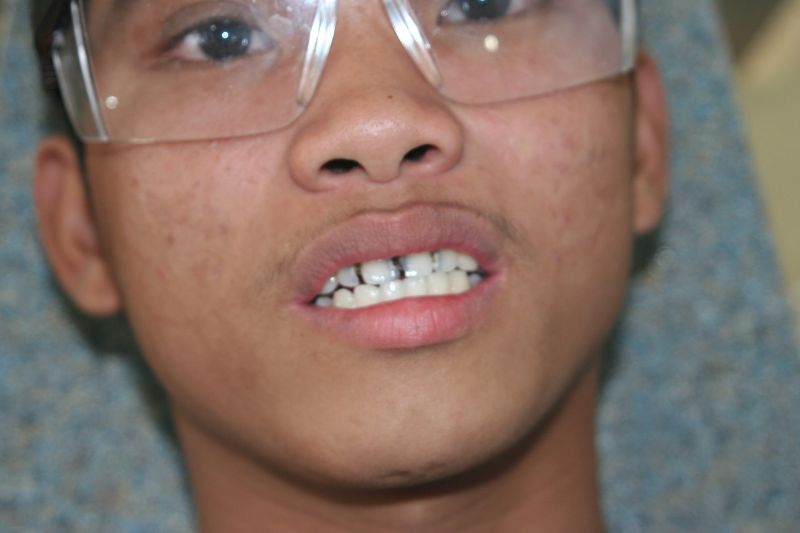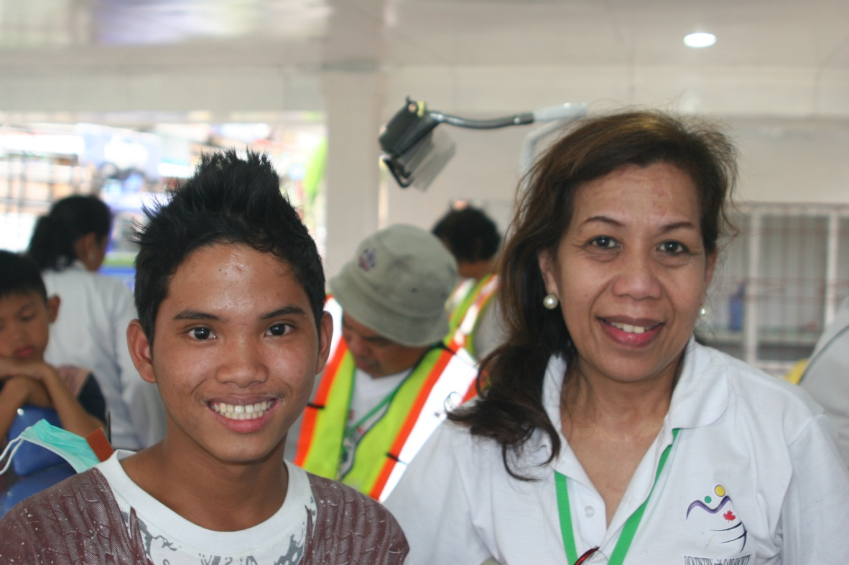

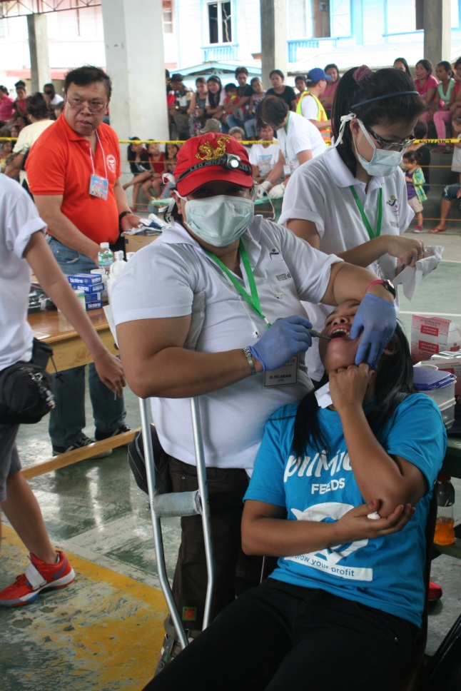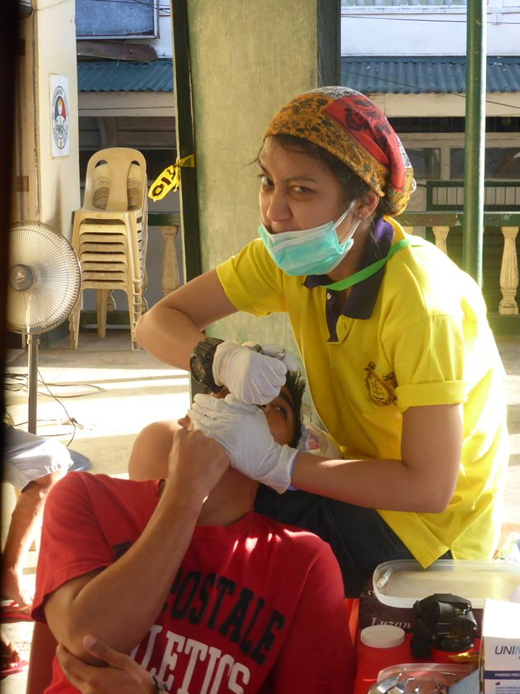

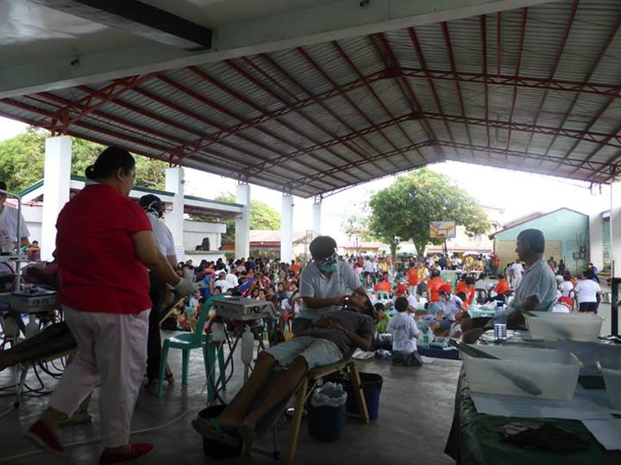

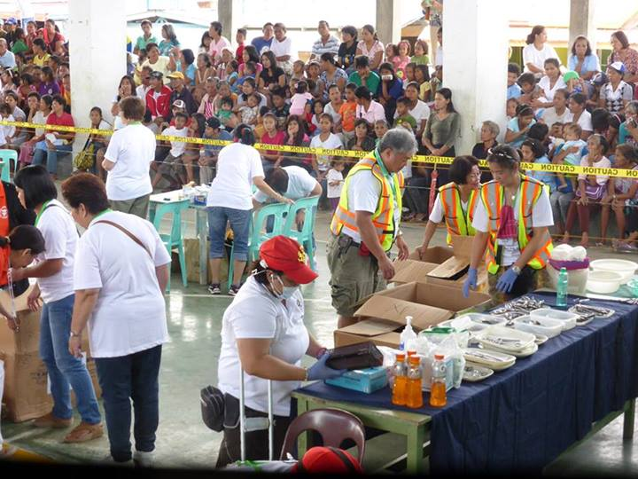

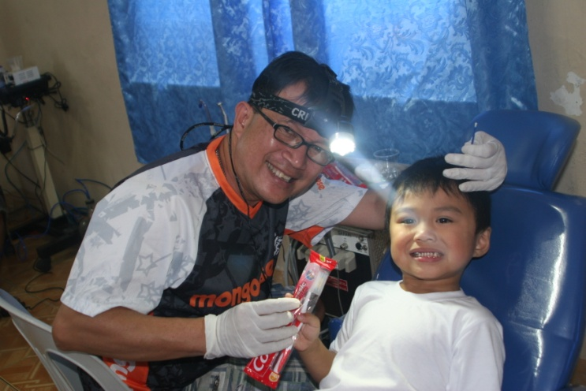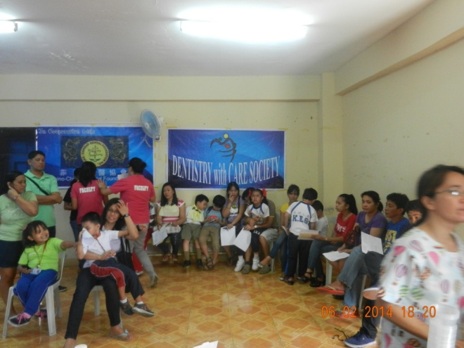

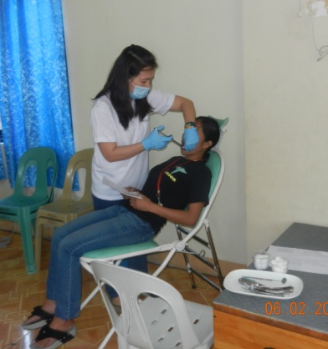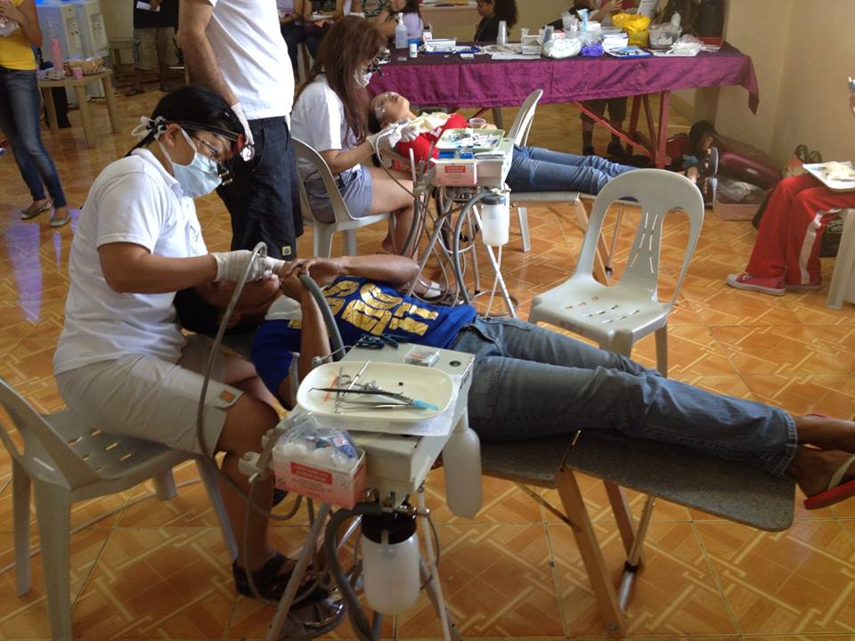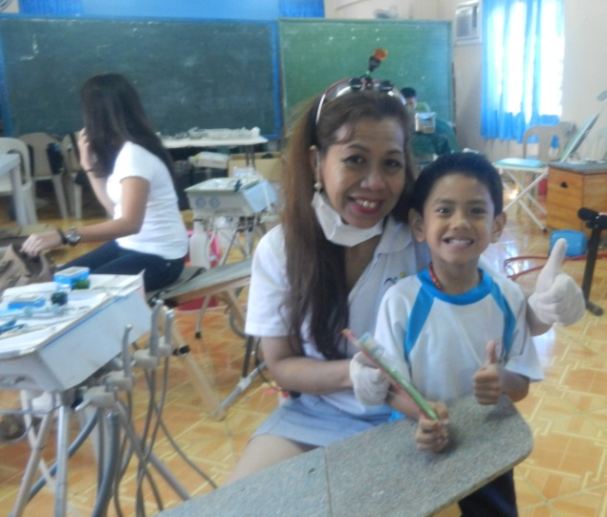

Site: Kipsi Elementary School - Batangas

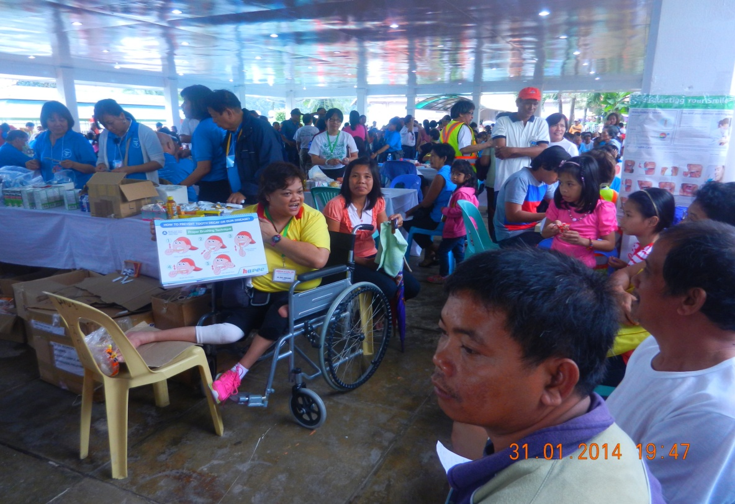

Health and dental education activities

Dental Team & Partners

